**Functional Document**

|  |  |
| --- | --- |
| **Application** | NGERP - Centra |
| **Service Bundle** | Sales Management |
| **Service Request** | VAT Transfer (Trade) |

**Description:**

In **Compiere (NGERP - Centra)**, **VAT Transfer** handles changes in VAT statuses between Declared, Undeclared, and WriteOff. It tracks Sales Transactions and updates the General Ledger with accurate Account Dates.

**Workflow Process:**

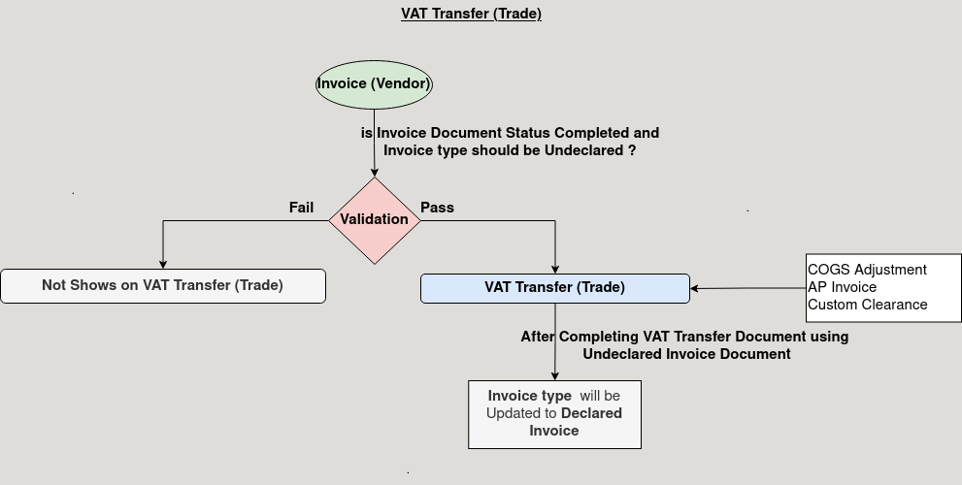

**Business Rules:**

* It is visible in both **HQ** and **ROW.**
* **Creation** is only possible in **ROW.**
* In **HQ** shows all region data.
* The VAT Transfer Type determines the movement between VAT statuses (e.g., Declared to Undeclared, WriteOff to Declared).